Creating S3 Bucket on AWS

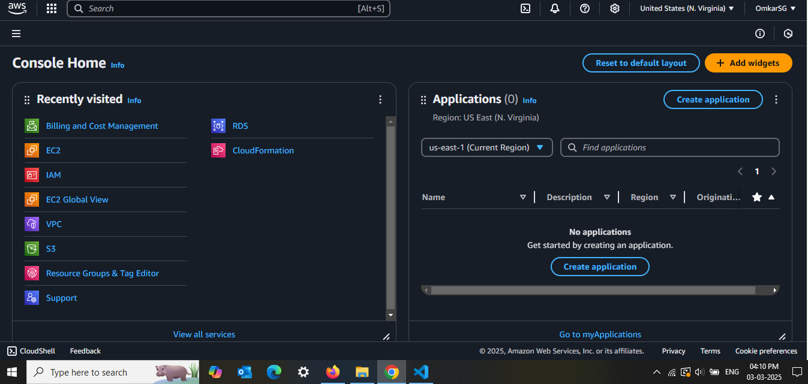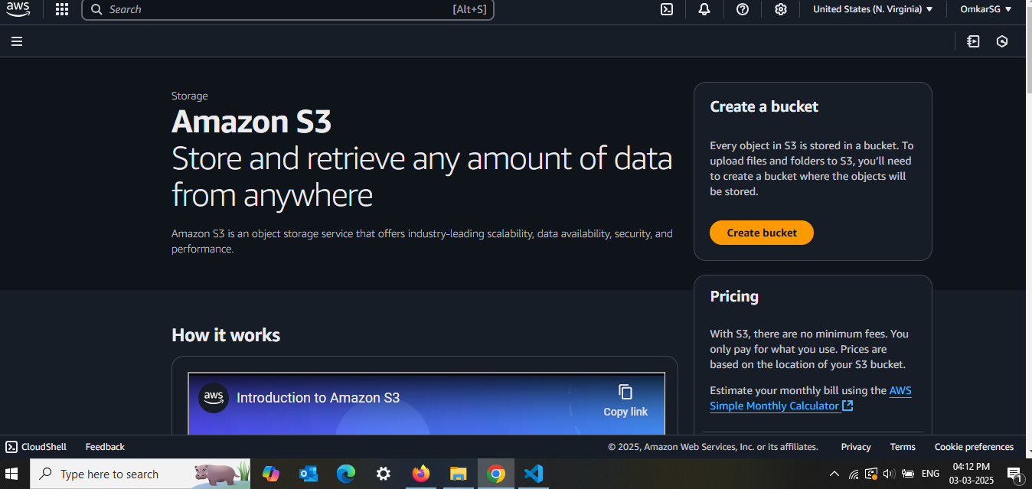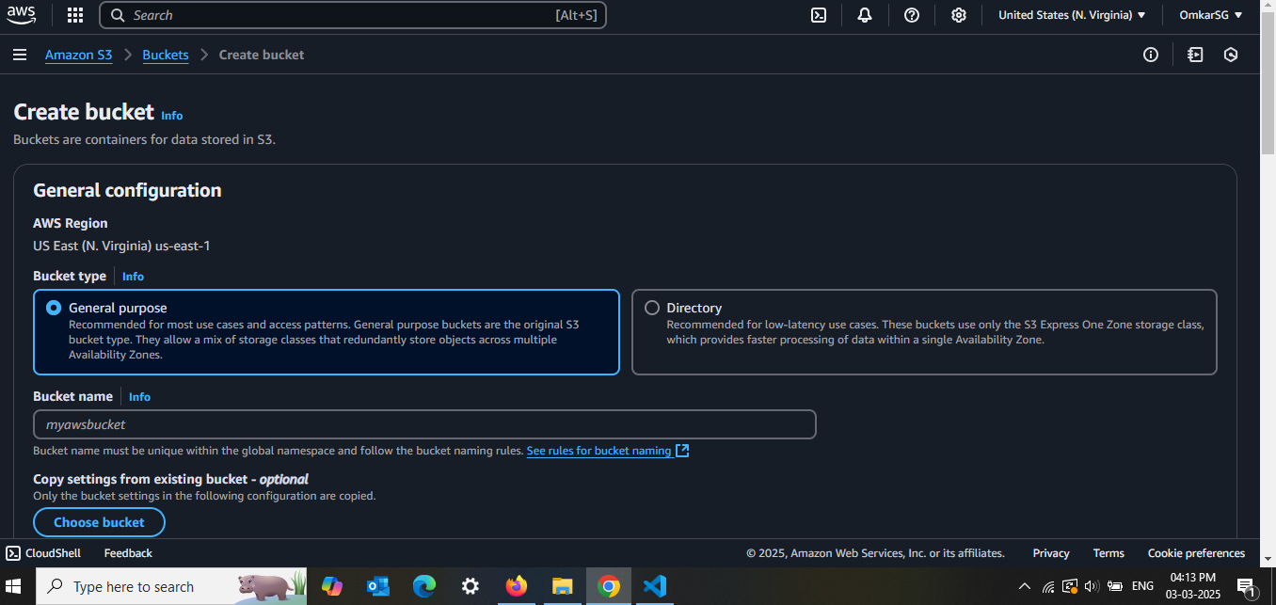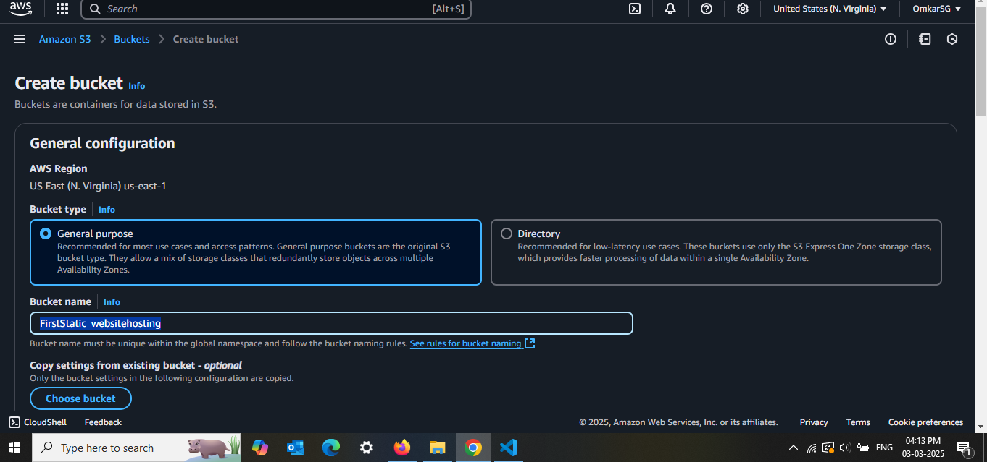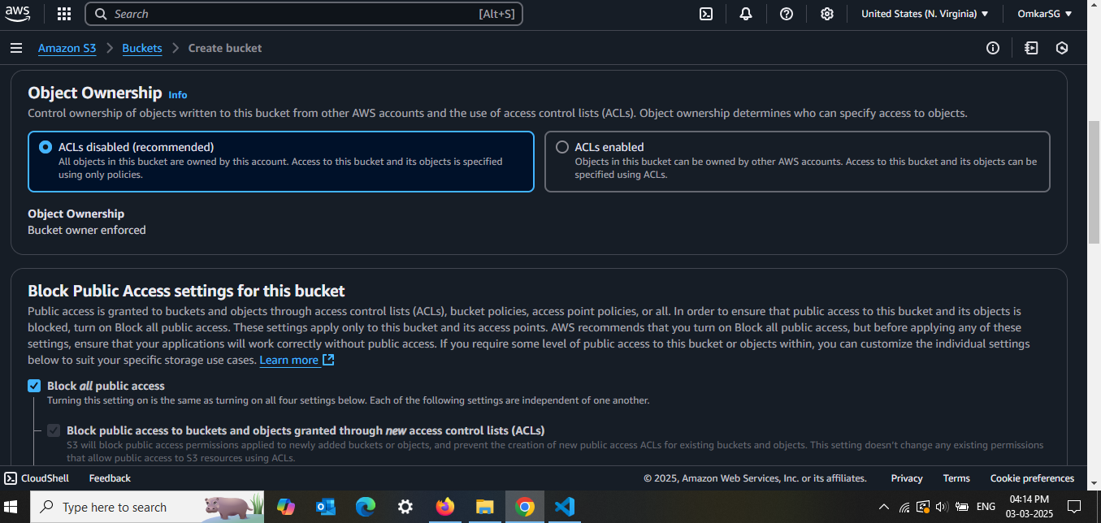**Uncheck "Block all public access"** (to make the site accessible)

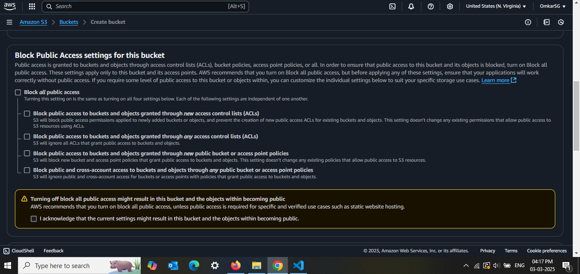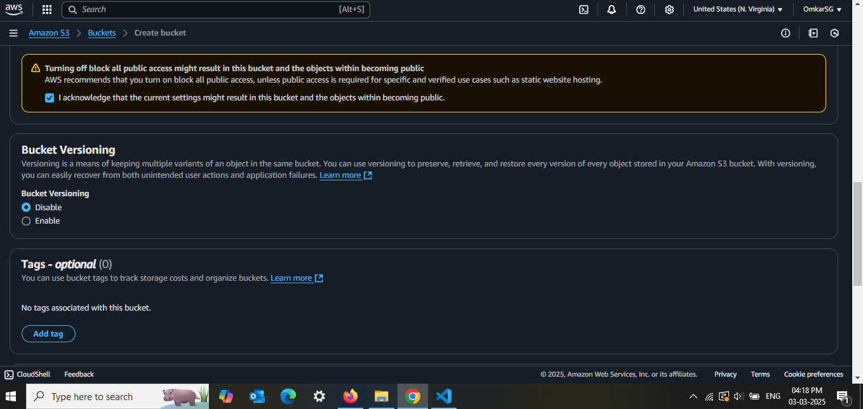Disabling Bucket key as Since this is a basic static website and not storing sensitive data, there's **no need for KMS encryption**, and this avoids extra costs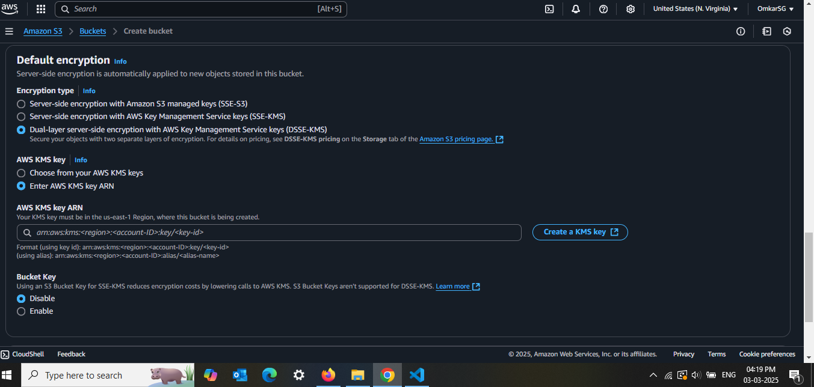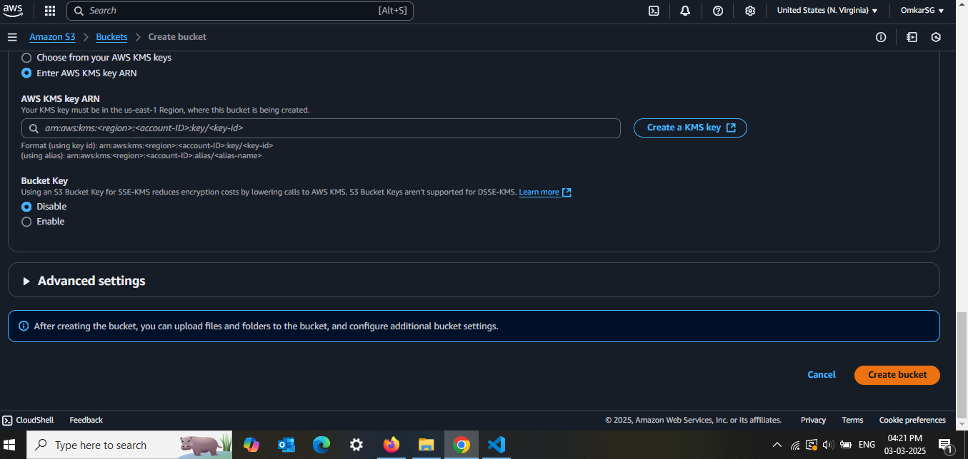✅ **Choose "Server-side encryption with Amazon S3 managed keys (SSE-S3)"**  
❌ **Do NOT select SSE-KMS or DSSE-KMS (to avoid extra costs)**  
❌ **Ignore "Bucket Key" settings (since it's only relevant for SSE-KMS)**

By following this, your **data remains secure, your website works perfectly, and you avoid unnecessary AWS charges**.

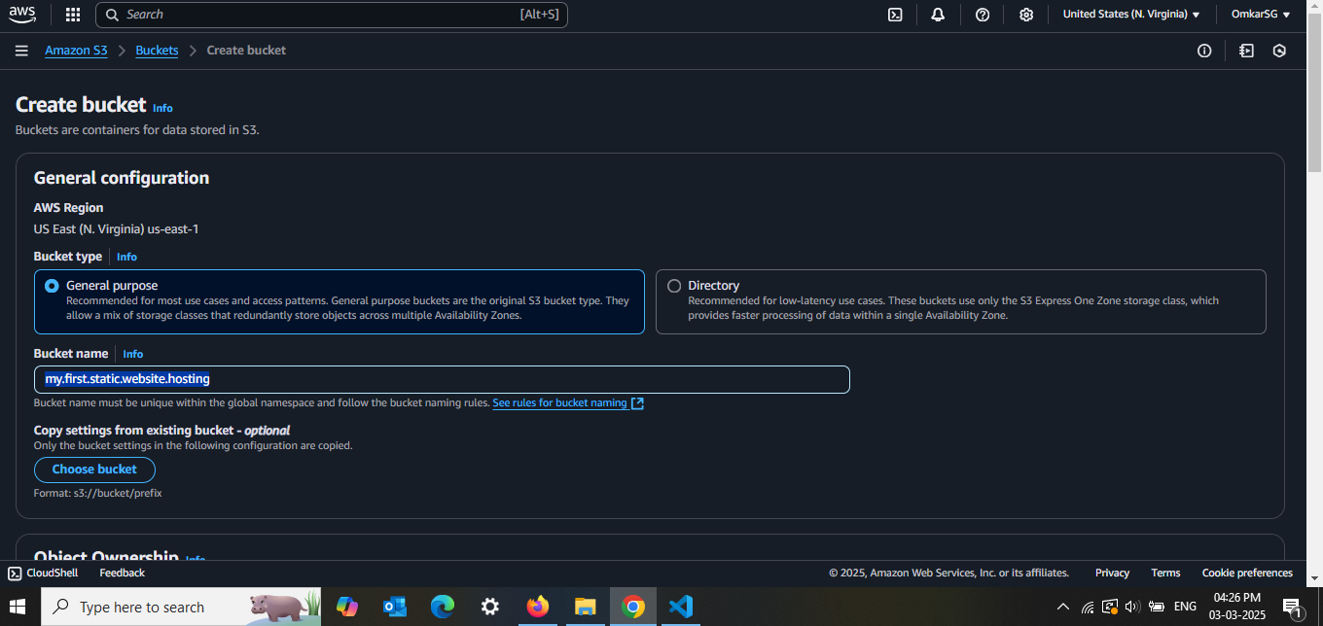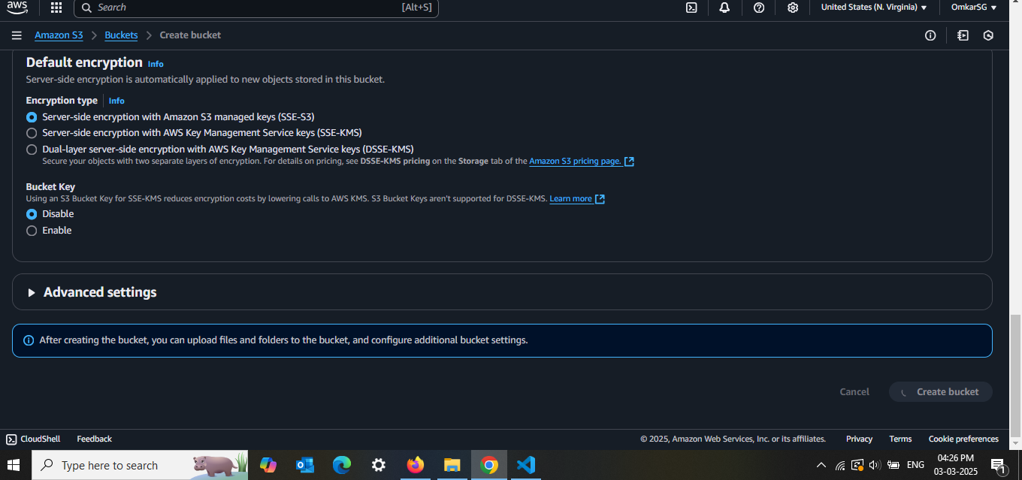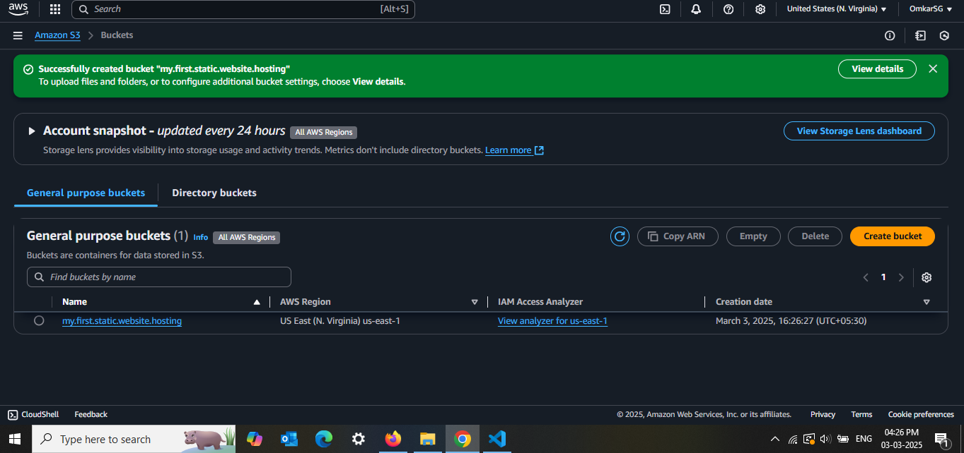2.Enable Static Website Hosting

**S3 bucket** → Go to the **Properties** tab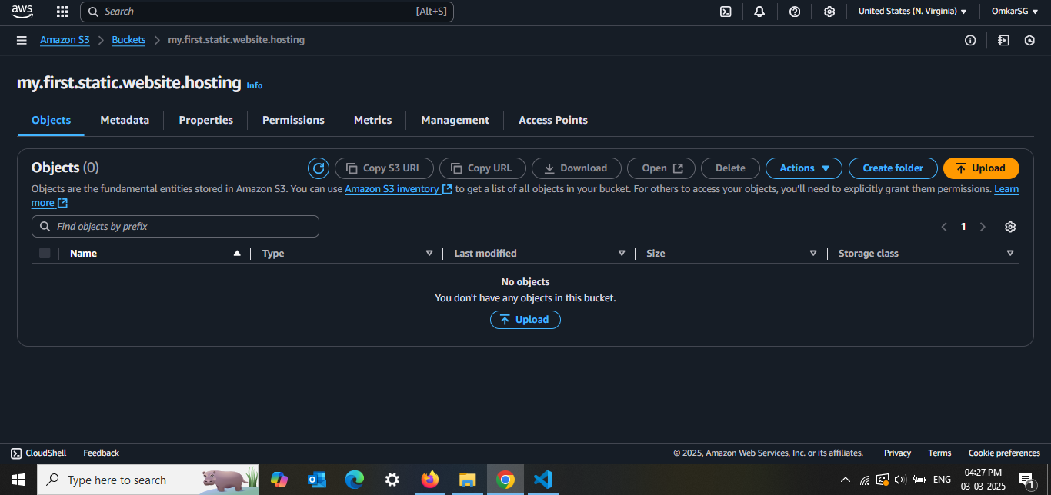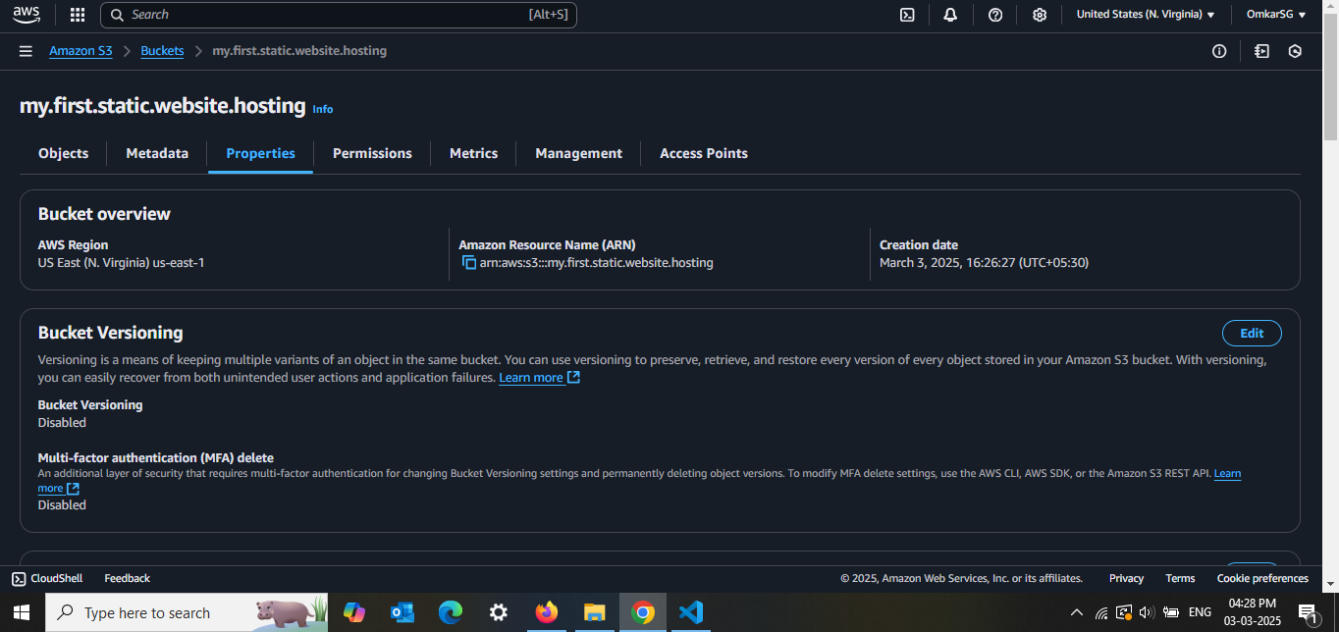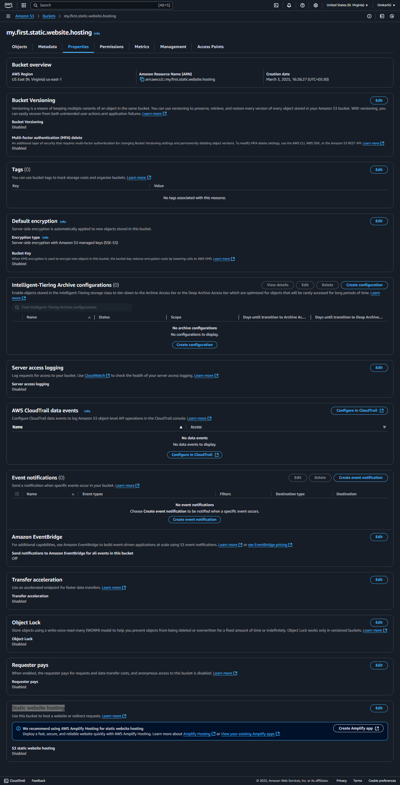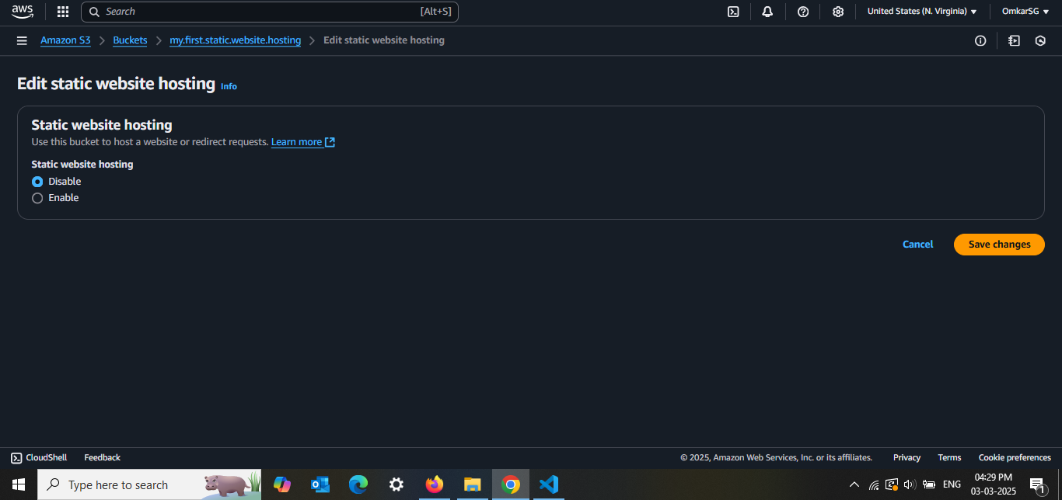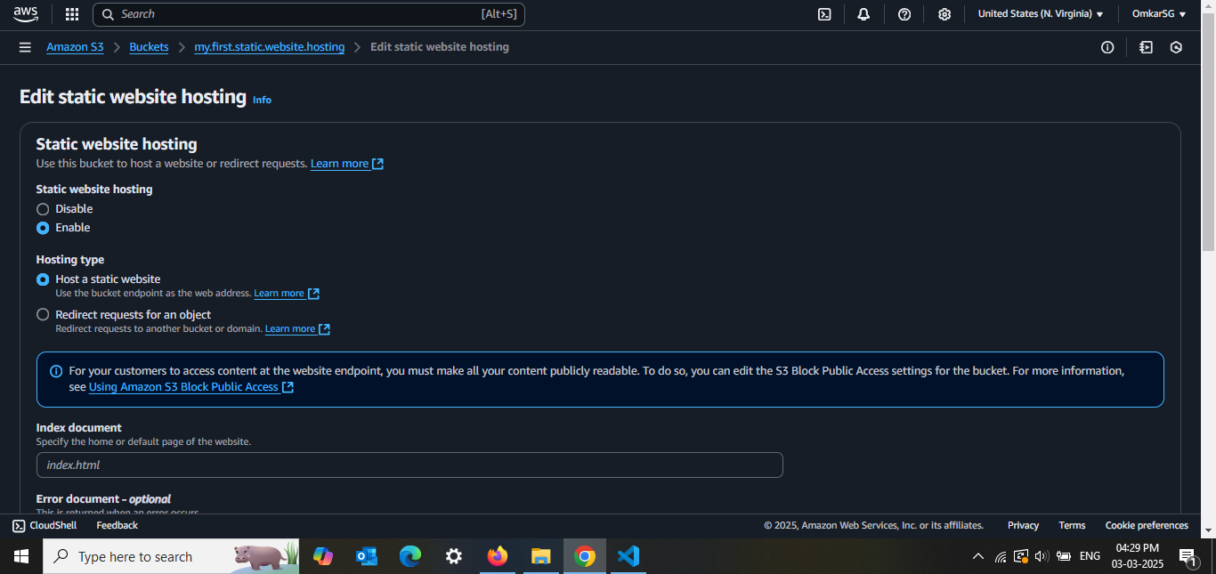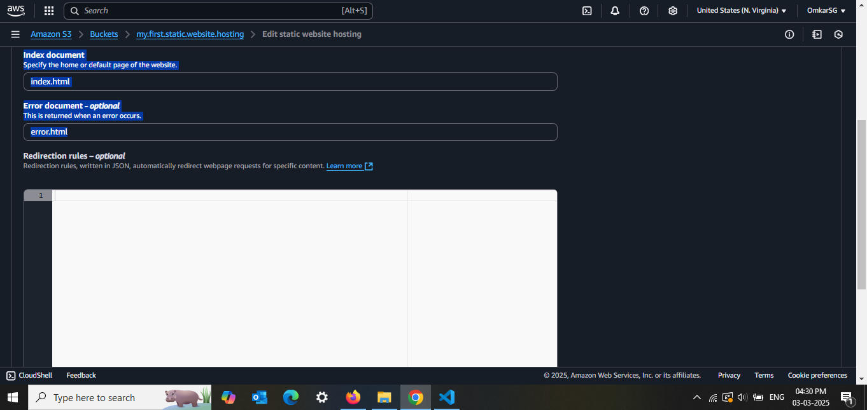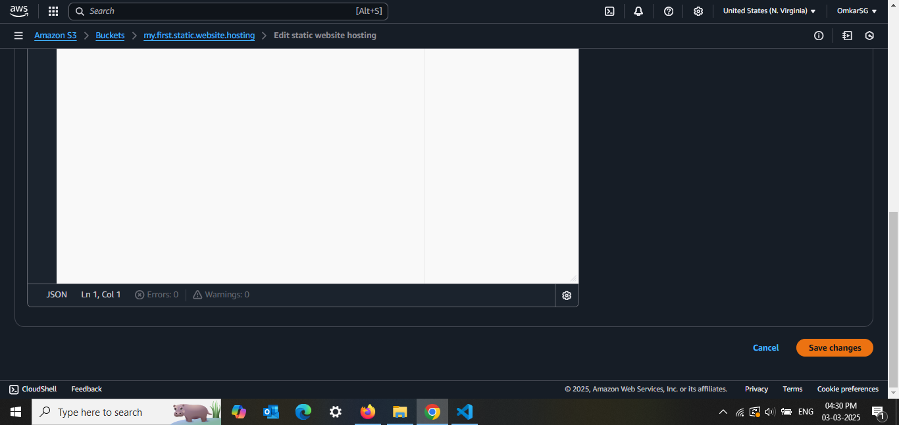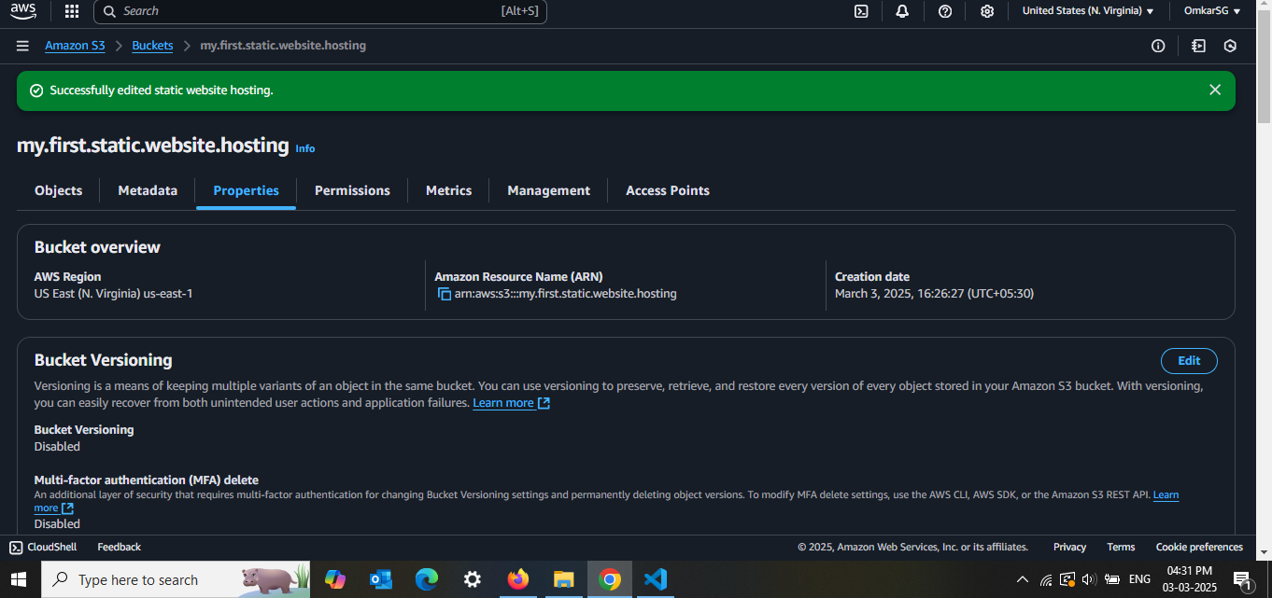3. Upload Website Files  
index.html  
error.html

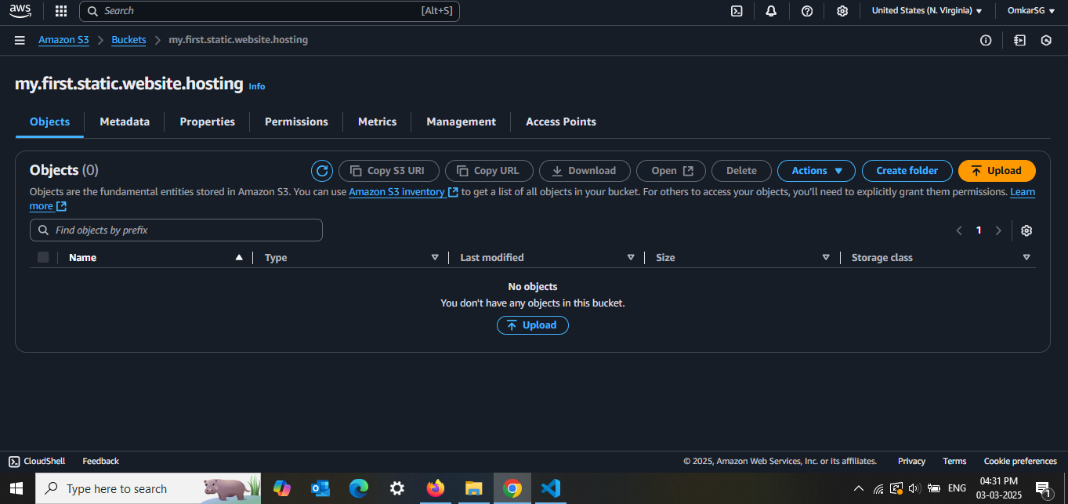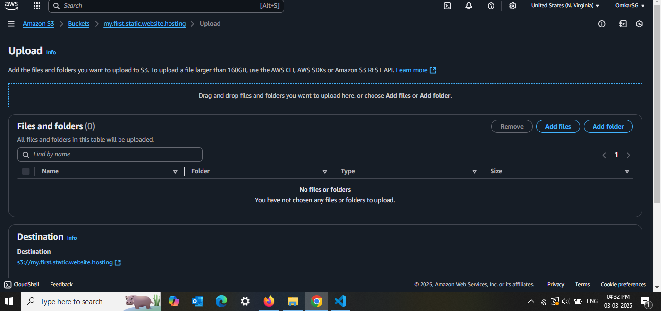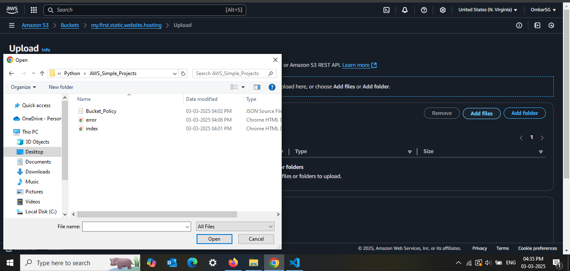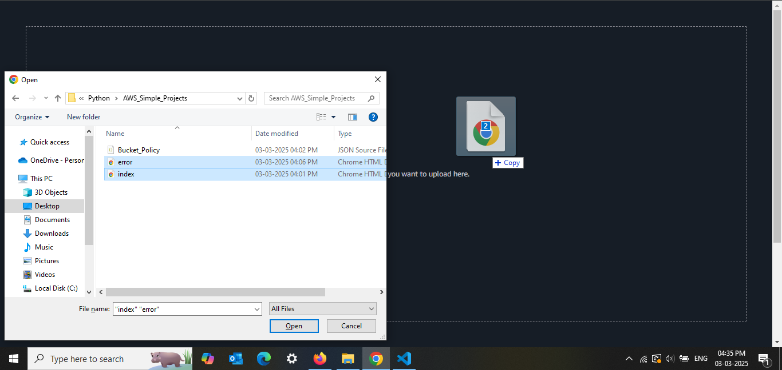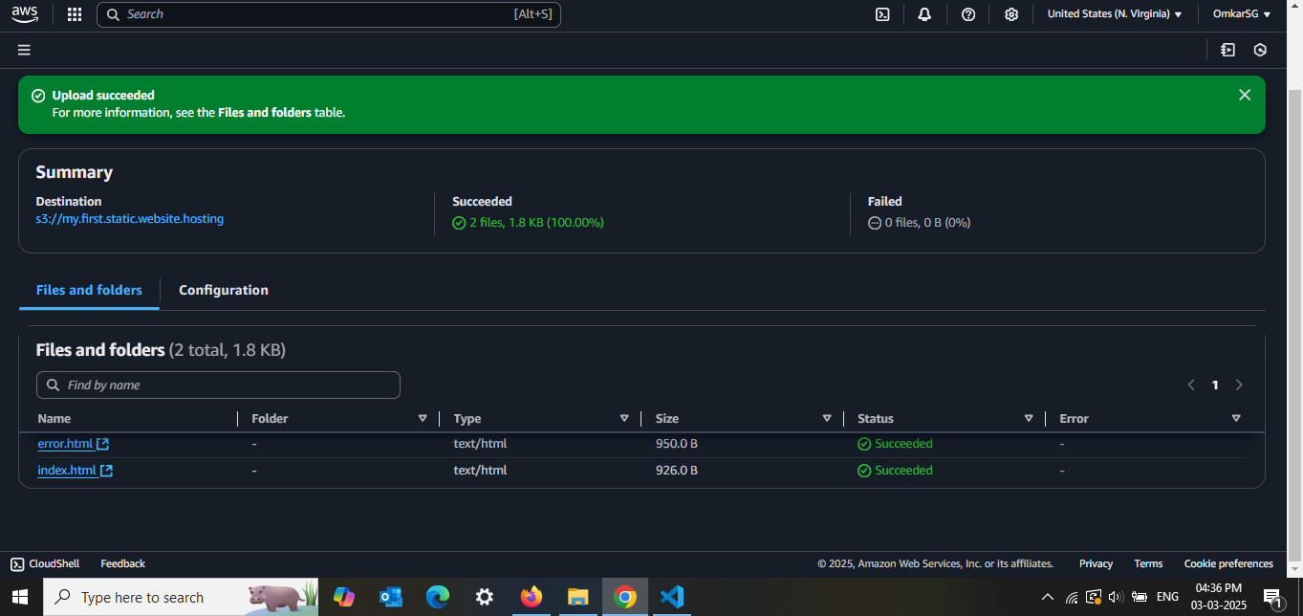4. Set Bucket Policy for Public Access

Go to **Permissions** → **Bucket Policy**

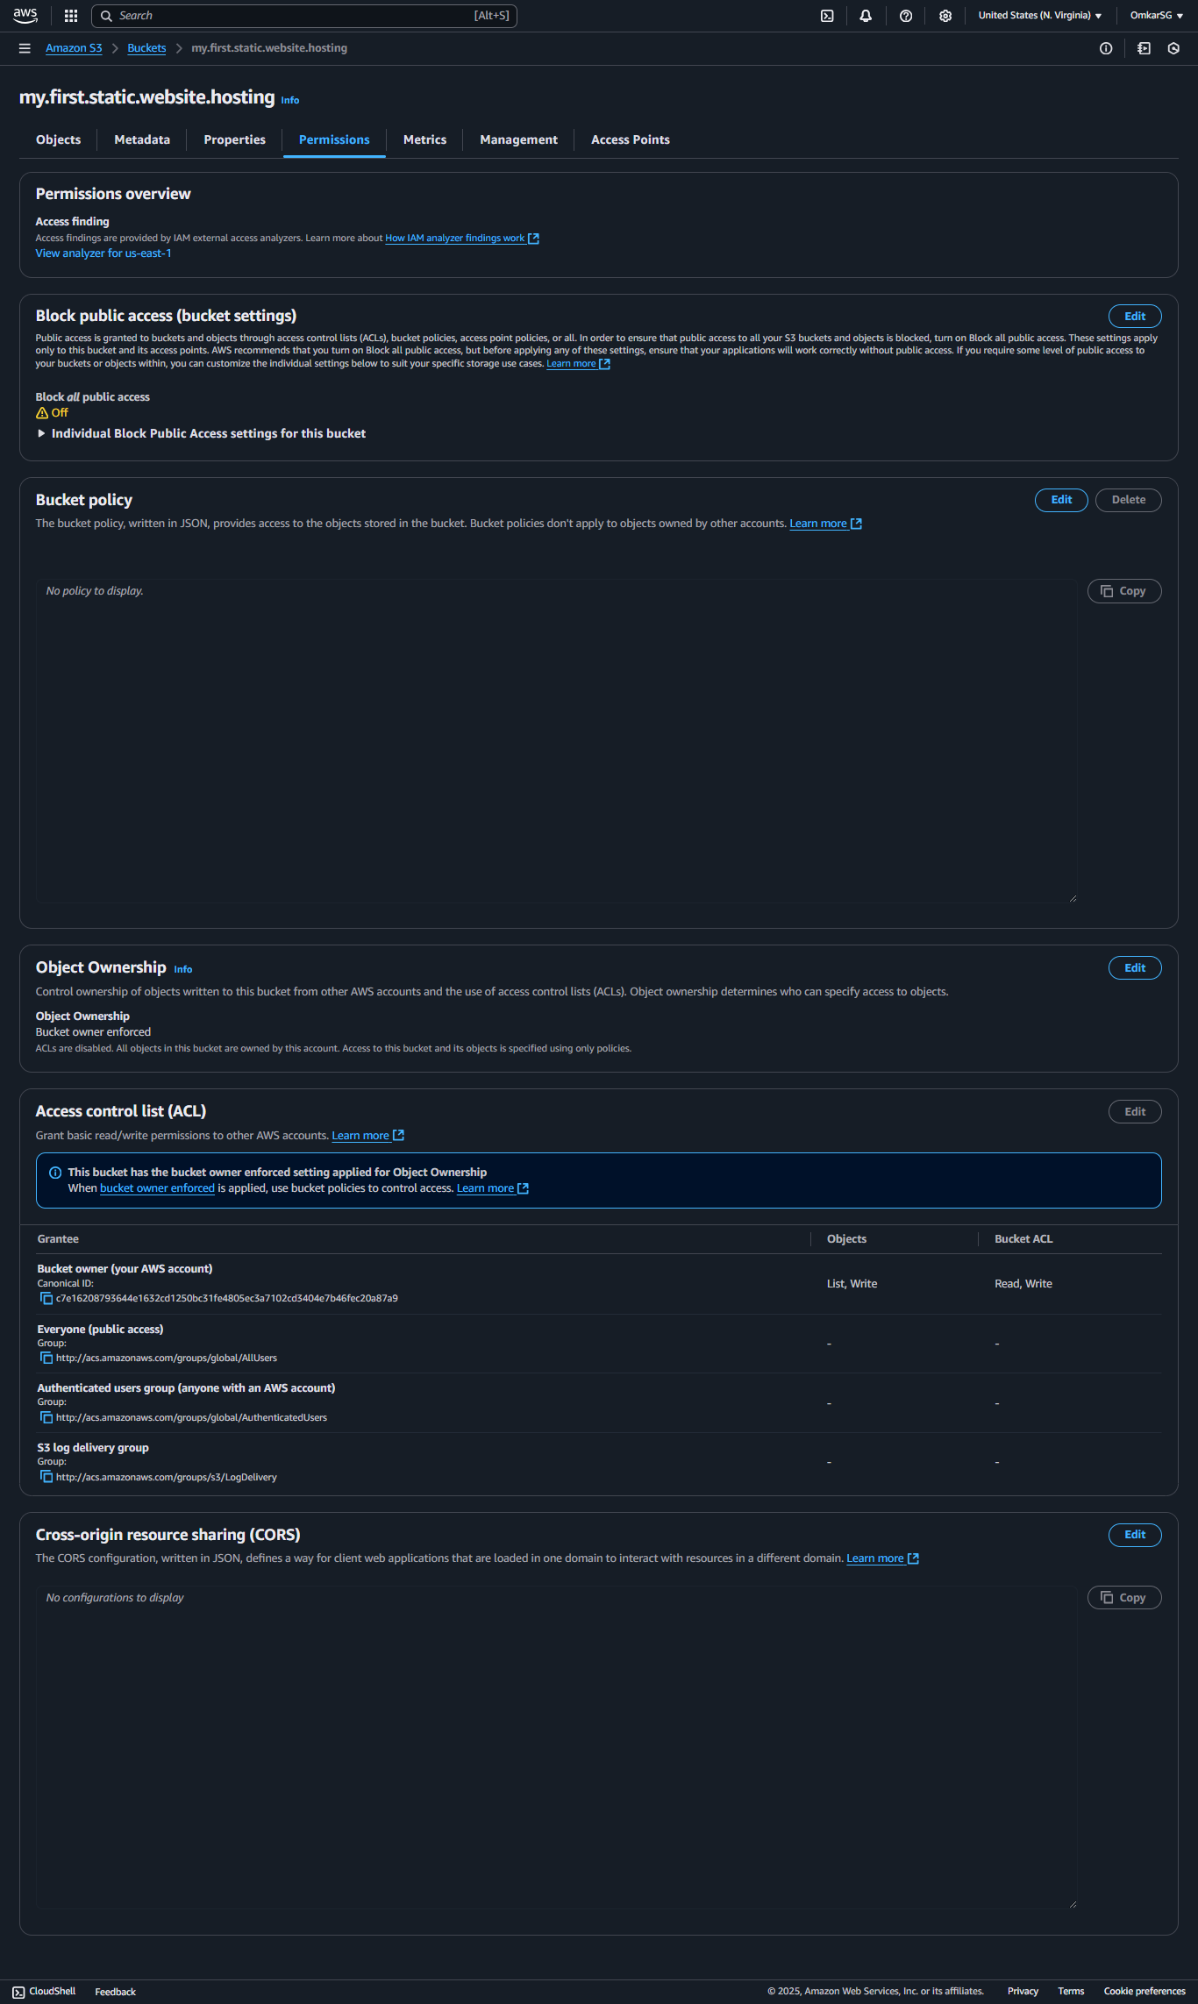

Bucket policy : -  
  
{

"Version": "2012-10-17",

"Statement": [

{

"Sid": "PublicReadGetObject",

"Effect": "Allow",

"Principal": "*",

"Action": "s3:GetObject",

"Resource": "arn:aws:s3:::my-static-website/*"

}

]

}

### **Breakdown of the Policy:**

* **"Effect": "Allow"** → Grants permission.
* **"Principal": "*"** → Allows access to **everyone (public access)**.
* **"Action": "s3:GetObject"** → Allows users to **retrieve (read) objects** from the bucket.
* **"Resource": "arn:aws:s3:::my-static-website/*"** → Applies to **all files inside the bucket** (/* means all objects).

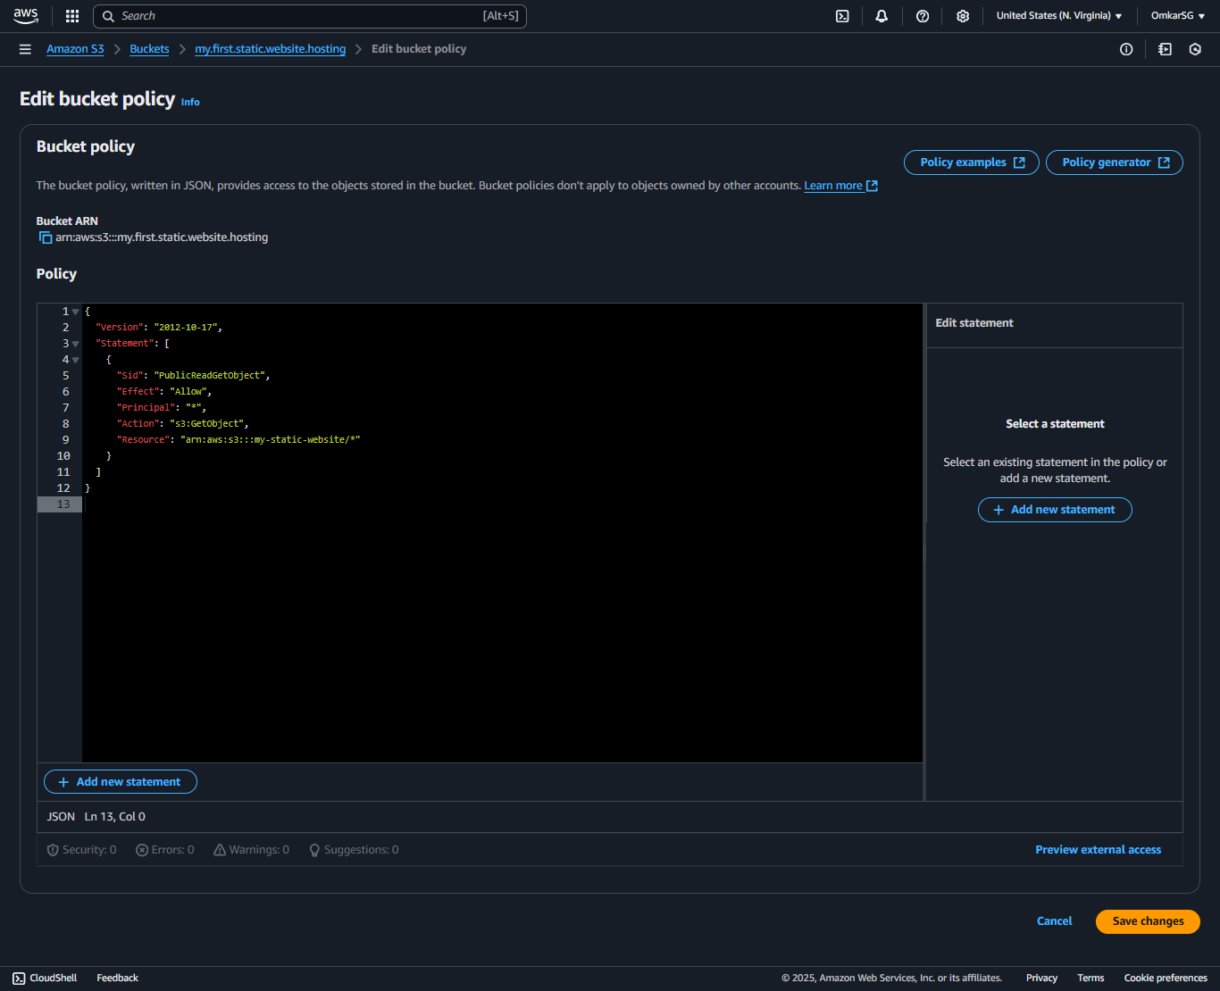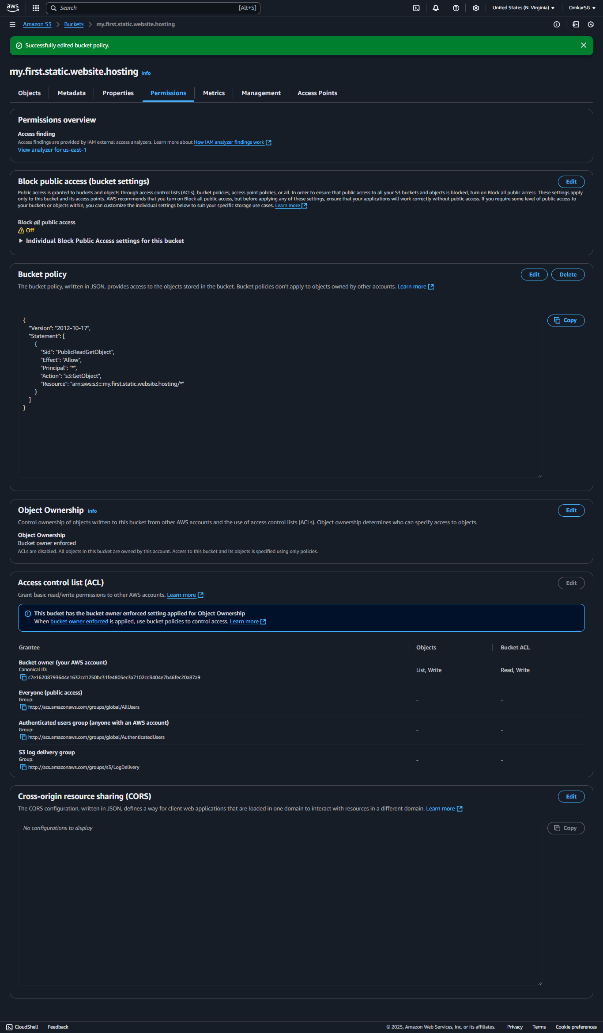

**5. Access Your Website**

* Copy the **Bucket Website Endpoint** from **Properties**
* **http://my.first.static.website.hosting.s3-website-us-east-1.amazonaws.com**
* Paste it into your browser—Your website is live! 🎉

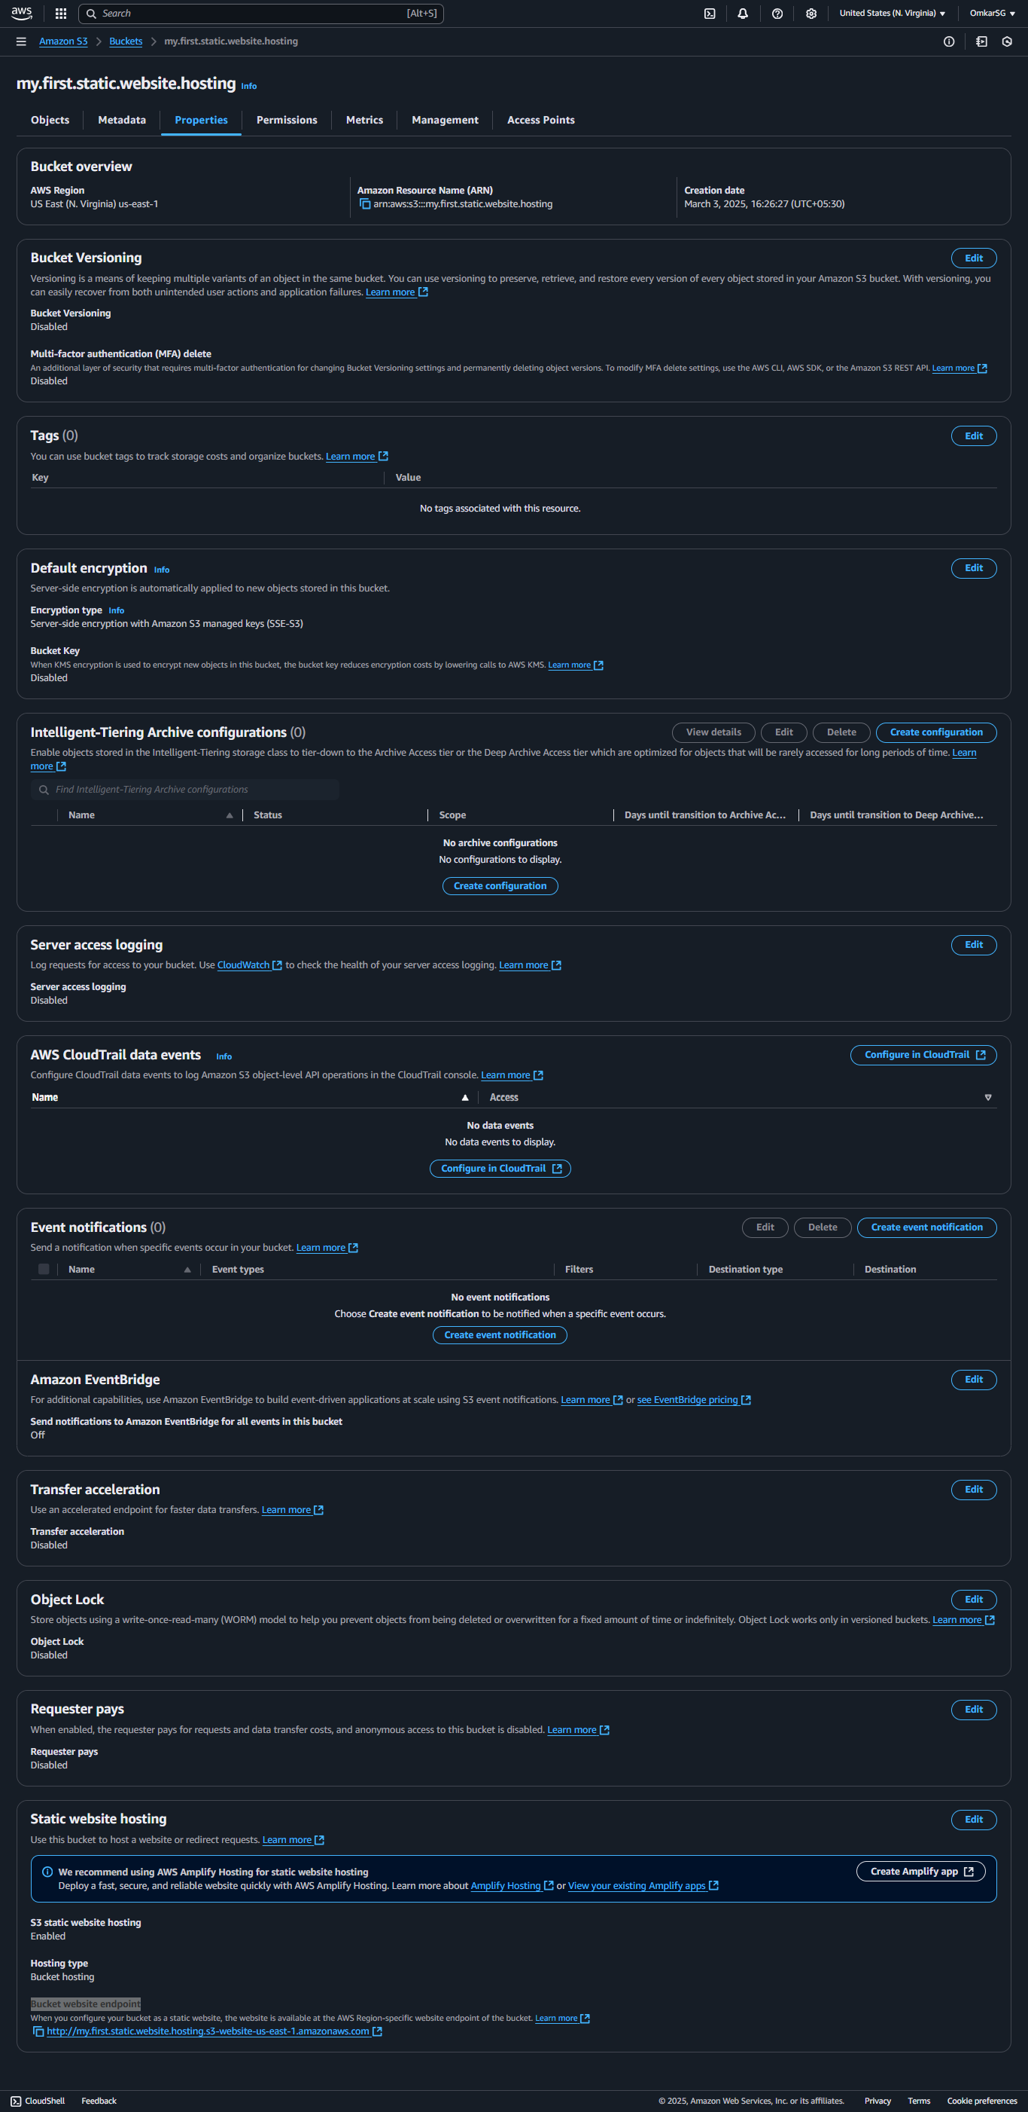

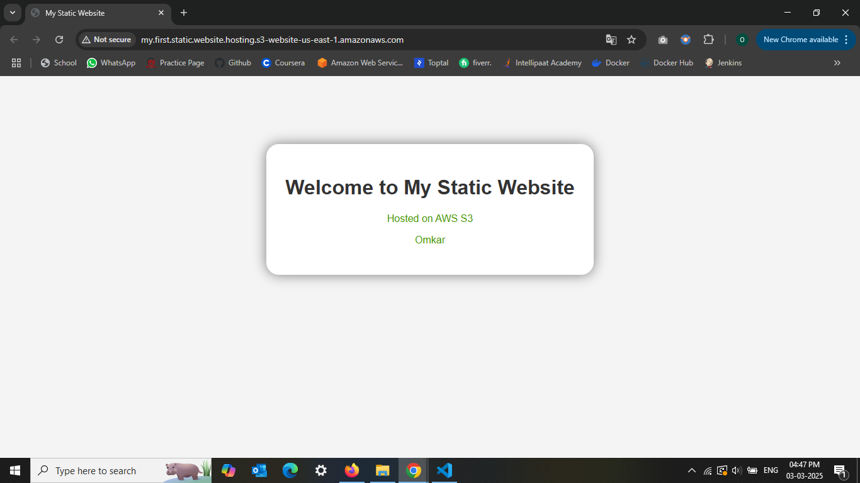7. Error page check

* Try visiting a random page (e.g., your-bucket-endpoint/randompage.html) to see if the error page appears

Original => <http://my.first.static.website.hosting.s3-website-us-east-1.amazonaws.com/>

Tets for error => http://my.first.static.website.1hosting.s3-website-us-east-1.amazonaws.com/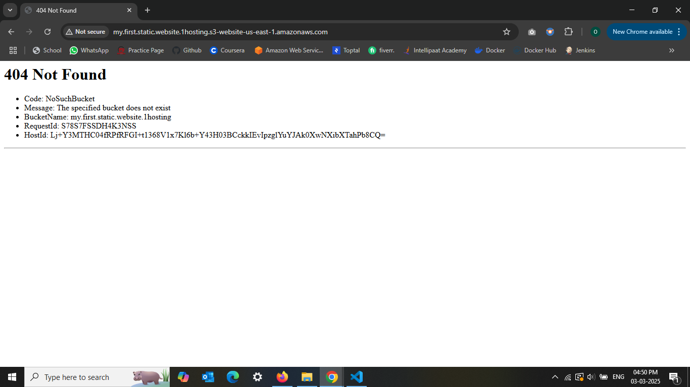

When you change the index.html to Index.html at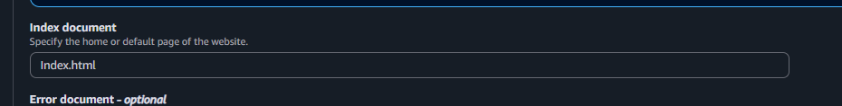to trigger error page

